Sustainable Waste Management Assistant Using Generative AI
Project Overview
Introduction
Waste management has become one of the biggest challenges in modern urban environments. Improper disposal of household, electronic, plastic, and hazardous waste leads to environmental pollution, health risks, and inefficient recycling practices. Many citizens lack awareness about proper waste segregation and disposal methods, making sustainable waste management increasingly difficult.
The Sustainable Waste Management Assistant Using Generative AI is a web-based smart city application developed to help users identify different types of waste, receive AI-powered disposal guidance, locate nearby recycling centers, and understand environmentally friendly waste management practices. The system combines Artificial Intelligence, cloud technologies, interactive maps, and data visualization to simplify waste disposal and promote sustainable living.
Developed as a practical college project, the application uses React.js for the frontend, Flask (Python) for backend services, Firebase Firestore for cloud database management, and the Groq API (Llama 3.3 70B Versatile Model) for intelligent waste classification and disposal recommendations. The application also integrates Leaflet.js with OpenStreetMap for location-based recycling center identification and Chart.js for visualizing user waste management statistics.
The platform provides users with an intelligent dashboard where they can classify waste items, receive recycling instructions, explore nearby collection centers, monitor their waste disposal history, and analyze recycling performance through interactive charts and reports

Problem Statement
Improper waste disposal and lack of public awareness contribute significantly to environmental pollution and inefficient recycling systems. Citizens often struggle to identify the correct disposal methods for different waste categories such as plastic, batteries, electronic waste, organic waste, and hazardous materials.
Existing waste management systems provide limited guidance and lack intelligent decision support. There is a need for an AI-powered solution that can automatically classify waste items, recommend environmentally safe disposal methods, provide recycling instructions, and help users locate nearby waste collection centers.

Objectives
- Develop an AI-powered waste classification system.
- Identify waste categories using Generative AI.
- Provide safe disposal instructions.
- Recommend recycling methods.
- Locate nearby waste collection centers.
- Track user waste disposal history.
- Display waste analytics using interactive dashboard.
- Promote sustainable environmental practices.

Features of the Project
- AI Waste Classification
- Image & Text Waste Identification
- Disposal Instructions
- Hazard Warnings
- Recycling Suggestions
- Nearby Collection Center Finder
- Google/OpenStreetMap Integration
- Dashboard Analytics
- Scan History
- Firebase Cloud Storage
- User-Friendly Interface
- Responsive Web Application

System Architecture
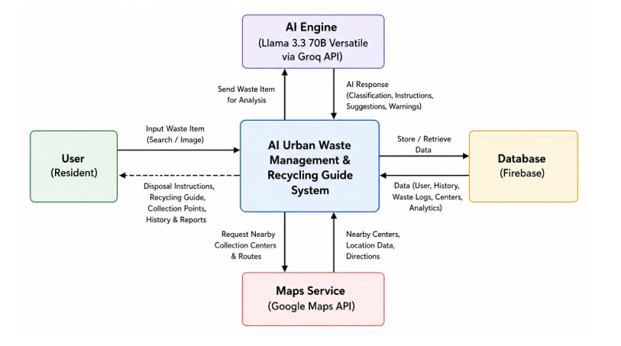

User
│
▼
React Web Application
│
▼
AI Waste Management System
│ │ │
▼ ▼ ▼
Groq AI API Firebase Maps Service
(Llama 3.3) Firestore (Leaflet.js)
│
▼
AI Classification & Disposal Guide

Technologies Used
Technology | Purpose
React.js | Frontend Development
Flask | Backend API Development
Python | Business Logic
Firebase Firestore | Cloud Database
Groq API | AI Waste Classification
Llama 3.3 70B | Generative AI Model
Leaflet.js | Interactive Maps
OpenStreetMap | Collection Center Locations
Chart.js | Dashboard Analytics
HTML5 | Web Structure
CSS3 | User Interface Design

Working of the Project
Step 1 – User Input
The user enters the name of a waste item or uploads an image through the application.
Step 2 – AI Classification
The Flask backend sends the waste information to the Groq API using the Llama 3.3 70B Versatile model. The AI identifies the waste category such as Plastic, Organic, Electronic, Hazardous, Glass, or Metal.
Step 3 – Disposal Recommendation
The AI generates detailed disposal instructions, recycling guidelines, hazard warnings, and eco-friendly recommendations based on the identified waste type.
Step 4 – Database Storage
The scan history, waste category, disposal recommendations, and user activity are stored securely in Firebase Firestore for future reference and analytics.
Step 5 – Collection Center Identification
The application uses Leaflet.js with OpenStreetMap to display nearby recycling centers and waste collection facilities based on the user's location.
Step 6 – Dashboard Analytics
Chart.js generates visual reports showing waste categories, recycling statistics, daily scanning activity, recyclable item percentage, hazardous waste count, and overall environmental contribution.

Skills Required
- React.js
- Python
- Flask
- Firebase Firestore
- JavaScript
- HTML5
- CSS3
- REST API
- JSON
- Prompt Engineering
- Generative AI
Result
The Sustainable Waste Management Assistant successfully combines Artificial Intelligence with cloud technologies to simplify waste classification and disposal. Users can identify waste types, receive AI-generated disposal guidance, locate nearby recycling centers, and monitor recycling activities through interactive dashboards. The platform encourages responsible waste disposal and supports sustainable environmental practices.

Conclusion
The Sustainable Waste Management Assistant Using Generative AI demonstrates how modern AI technologies can improve environmental sustainability through intelligent waste management. By integrating Generative AI, cloud databases, interactive maps, and visualization tools, the application provides users with an efficient, user-friendly platform for waste classification, recycling guidance, and environmental awareness. The project highlights the practical application of Artificial Intelligence in building smarter, cleaner, and more sustainable cities.

